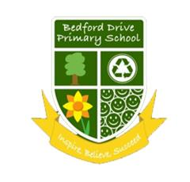
YEAR 5 READING/WRITING
CURRICULUM PLAN 2021-2022

 | AUTUMN 1 | AUTUMN 2 | SPRING 1 | SPRING 2 | SUMMER 1 | SUMMER 2
Cross  Curricular Themes | Tudors |  | Victorians | Refugees | Slavery | Conservation
 | Animals Including Humans | Properties and changes of materials | Forces | Earth and Space  Stem project | Living things and their environments
Literacy  Counts  Book | 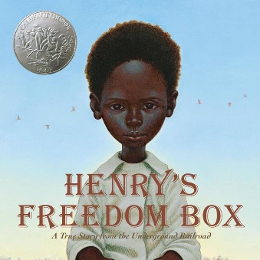 | 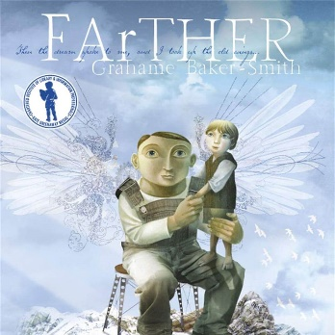 | 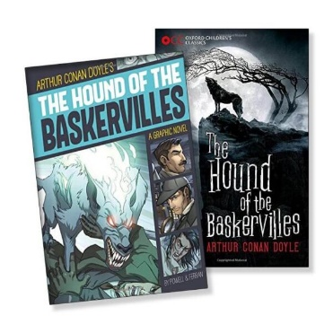 | 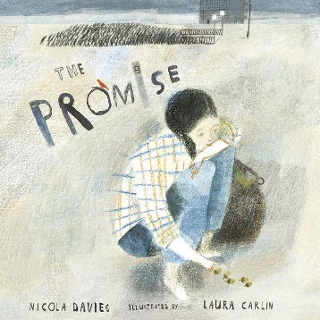 | 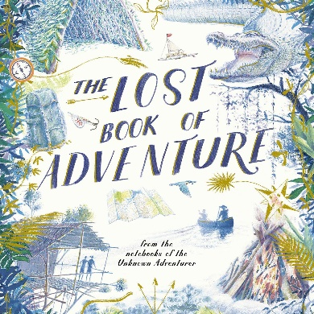 | 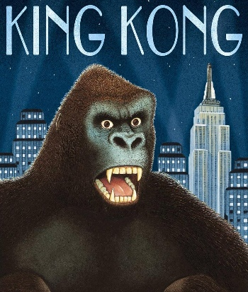
 | Diary Entry  Biography | Setting description  Non-fiction letter writing | Cliff hanger narrative  Formal Report | Character Description  Newspaper Report | Survival Narrative  Explanation | Balanced Argument  Dilemma Narrative
Whole  Class  Novel | 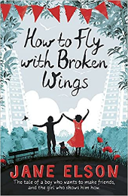  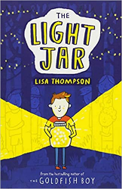 |  | 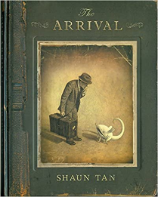  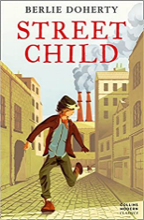  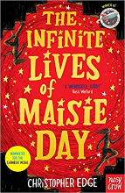  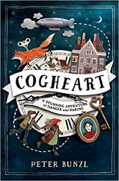 |  | 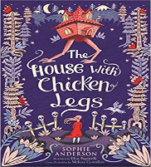  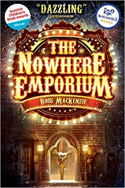  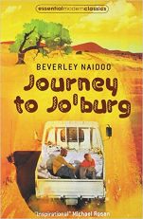  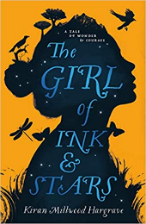
Whole  Class  Reading  Themes | GREAT OPENINGS  SONGS FROM MUSICALS  NOVELS VOL 1  MEDIEVAL MONARCHS  NOTABLE PEOPLE VOL 1  EQUALITY  NIGERIA | CHANGING MATERIALS  LIFE CYCLES  CHILDREN’S CLASSICS VOL 1  KATE DECAMILLO  CHRISTMAS  DISNEY SONG | ENERGY AND FORCES PICTURE BOOKS VOL 1  POETRY VOL 1  BEETLES  SHACKLETON  ANTARCTIC EXPLORER | FRANK COTTRELL BOYCE  NOTABLE PEOPLE VOL 2  PICTURE BOOKS VOL 2  SONGS  NOVELS 2 | ISLANDS  TITANIC  SPACE  CIRCUSES  CHILDRENS CLASSIC VOL 2  SIA  POETRY VOLUME 2 | BRAZIL  RAINFORESTS  MIDDLE EASTERN COUNTRIES  MICHAEL MORPURGO

