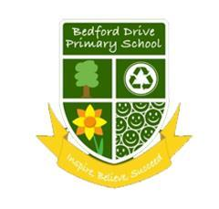
YEAR 4 READING/WRITING
CURRICULUM PLAN 2021-2022

 | AUTUMN 1 | AUTUMN 2 | SPRING 1 | SPRING 2 | SUMMER 1 | SUMMER 2
Cross  Curricular Themes | Romans |  | Anglo Saxons and Vikings |  | Refugees  Conservation
 | States of Matter | Volcanoes and Earthquakes | Electricity | Sound | Animals including humans | Living Things and their habitats
Literacy  Counts  Book | 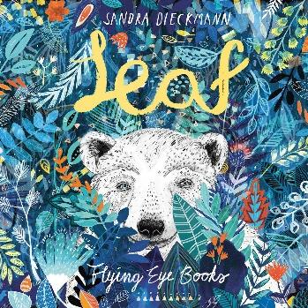 | 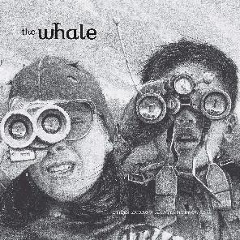 | 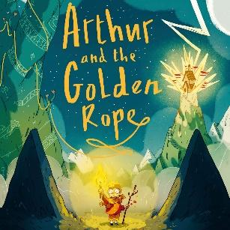 | 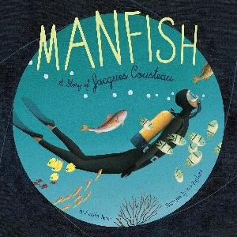 | 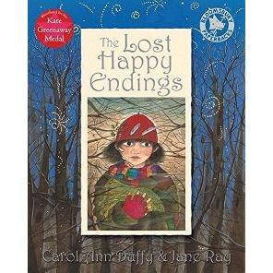 | 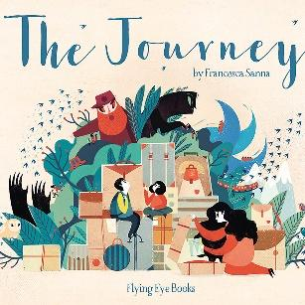
 | Outsider Narrative  Character Description | Setting Description  Newspaper | Myth Narrative  Information | Invention  Recount | Twisted Narrative  Letter | Refugee  Diary writing
Whole  Class  Novel | 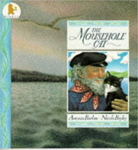  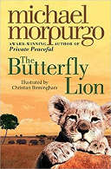 | 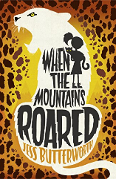 | 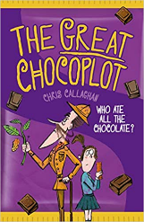 | 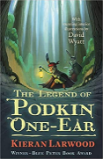 | 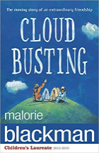 | 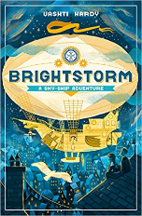
Whole  Class  Reading  Themes | Mental Health  States of Matter  Jennifer Killick  Picture Books Volume 1  Black History Month | Armistice Day  Sports People  Songs From Musicals  Disney Songs  Romans  Recycling Week | Chinese New Year  Electricity  Vikings  International Women’s Day  Holocaust Memorial Day | Children’s Classics Vol 1  Poetry Volume 1  Notable People Volume 2  Rivers  Migration | Guy Bass  Notable People Volume 1  Witches and Wizards  Teeth  Children’s Classics Vol 2 | Habitats  Rabbits  Poetry Volume 2  Songs  Money

