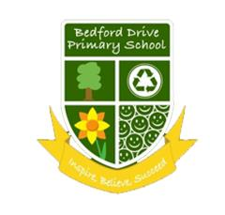
YEAR 3 READING/WRITING
CURRICULUM PLAN 2021-2022

 | AUTUMN 1 | AUTUMN 2 | SPRING 1 | SPRING 2 | SUMMER 1 | SUMMER 2
Cross  Curricular Themes | Stone age |  | Egyptians | Refugees | Ancient Greece | Conservation
 | 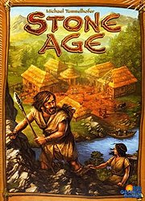 |  | 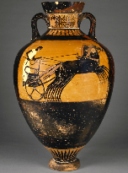 | 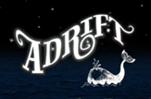 |  | 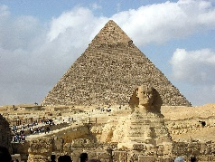
Literacy  Counts  Book | 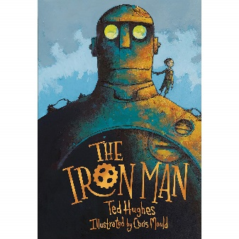 | 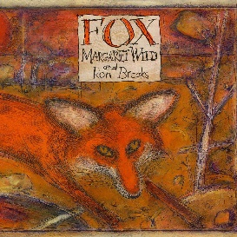 | 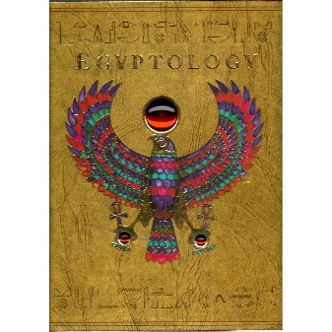 | 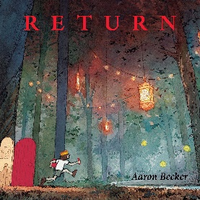 | 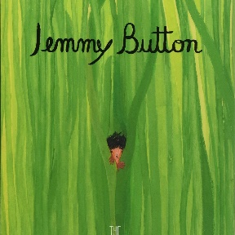 | 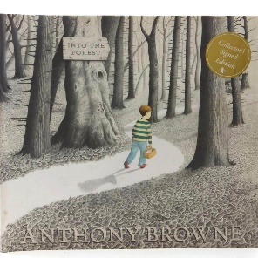
 | Threat Narrative  Explanation | Fable Narrative  Information | Egyptian Mystery Narrative | Setting Narrative  Report | Return Narrative  Letter to recount | Lost Narrative  Newspaper
Whole  Class  Novel | 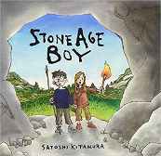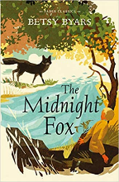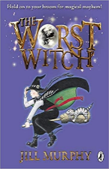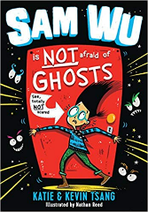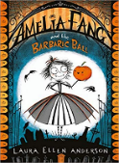 |  | 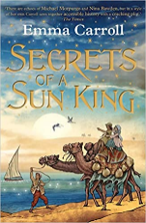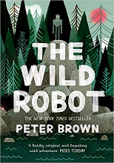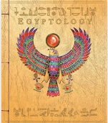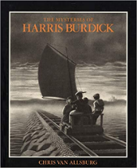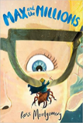 |  | 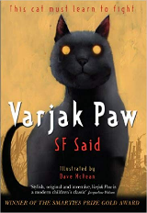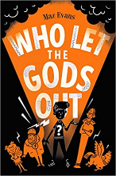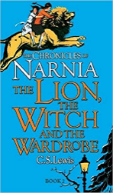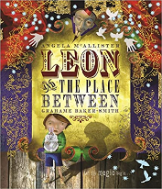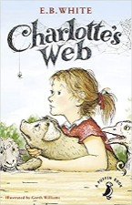
Whole  Class  Reading  Themes | Anne Fine  Disney Songs  Internet Safety  Novel vol 2  Songs  Rocks and Fossils | Children’s classic Vol 1  Monsters  Novels vol 1  Picture books 1  Spiders  Prehistoric Britain | Colours  Hearing impairment  Keeping healthy  Notable people vol 2  Plants  Poetry Volume 1 | Children’s classic Vol 2  Different cultures  Forces  Lighthouses  Towns, cities and villages | Dick King Smith  Light and shadows  Phillip Reeves and Sarah McKintyre  Songs from musicals  Robots  Poetry Volume 2 | Greece  Notable people vol 1  Picture books 2  Shang dynasty  Weather  Roald Dahl

