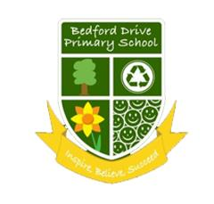

**YEAR 2 READING/WRITING**

**CURRICULUM PLAN 2020-2021**

|  |  |  |  |  |  |  |
| --- | --- | --- | --- | --- | --- | --- |
|  | **AUTUMN 1** | **AUTUMN 2** | **SPRING 1** | **SPRING 2** | **SUMMER 1** | **SUMMER 2** |
| **Cross**  **Curricular Themes** | Living Things and Habitats | The Beatles | Global Flight | STEMterprise  Plants | The Great Fire of London | Animals, including Humans  Conservation and Chester Zoo |
| Colorful Map Of Countries Of The United Kingdom With Indication ...UK Locational Knowledge | DT Decorations | Everyday Materials | Easter-  Palm Sunday | Light | Wheels and Axels |
| **Literacy**  **Counts Book** | The Night Gardener  The Night Gardener | A River  A River | The Bog Baby  The Bog Baby | Grandad’s Island  Grandad's Island | The King Who Banned the Dark  The King Who Banned The Dark | Rosie Revere EngineerRosie Revere Engineer |
| Setting Narrative  Diary writing | Circular Narrative  Letter | Finding Narrative  Instructions | Return Narrative  Information | Mistake Narrative  Information writing (Rules) | Invention Narrative  Explanation |
| **Whole**  **Class**  **Novel** |  | |  | | https://images-na.ssl-images-amazon.com/images/I/515mmhM663L._SX384_BO1,204,203,200_.jpg | |