Year 2 Curriculum Map 2022 / 2023
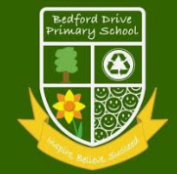 | Whole School Connector:  ‘A Moment in Time’  (History & Music) |  |  |  | Whole School Connector:  ‘Adrift’  (PSHE / Values / UNICEF)  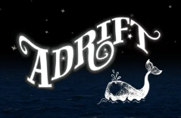 | Whole School Connector:  ‘The Way Things Work’  (Science, DT, Computing) |  | Whole School Connector:  ‘Think Global’  (Geography & Art)
 | Thrive Model: Self |  |  |  | Thrive Model: Society |  |  |  | Thrive Model: Global
English  (Literacy Counts Units of Work) | 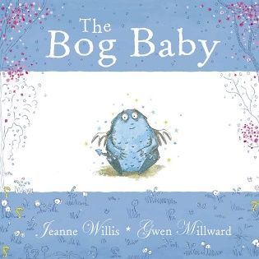 |  | 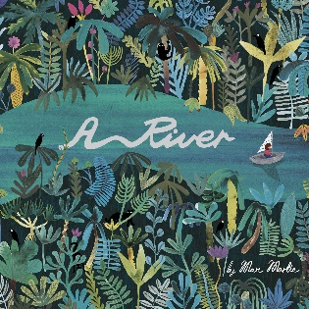 |  | 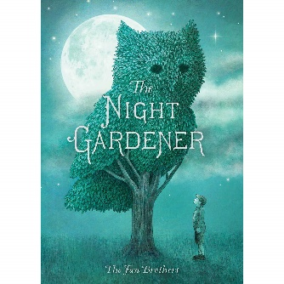 | 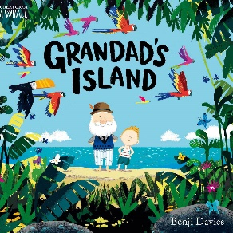 |  | 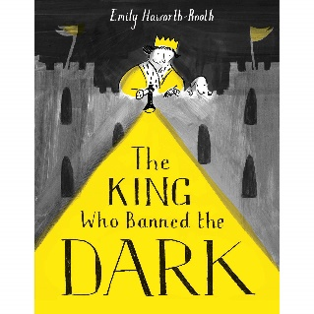 |  |  |  |  | 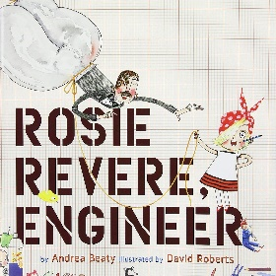
 | Finding Narrative  Instructions |  | Circular Narrative  Letter |  | Setting Narrative  Diary writing | Return Narrative  Information |  | Mistake Narrative  Information writing (Rules) |  |  |  |  | Invention Narrative  Explanation
Class Novels | 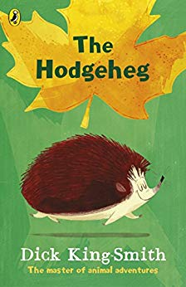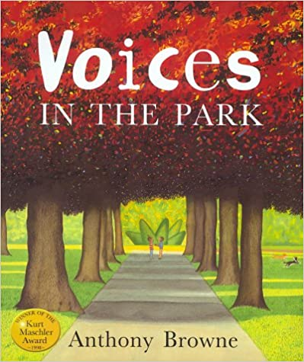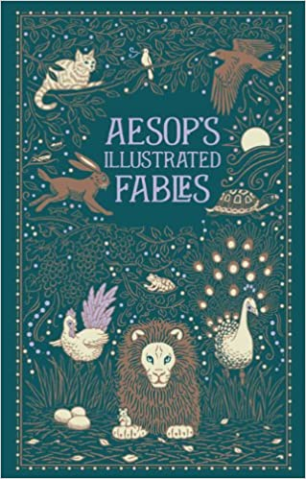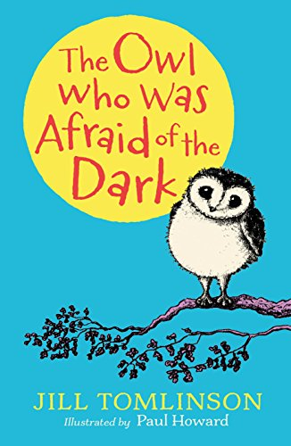 |  |  | 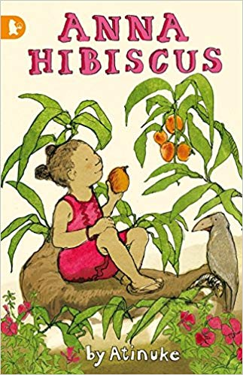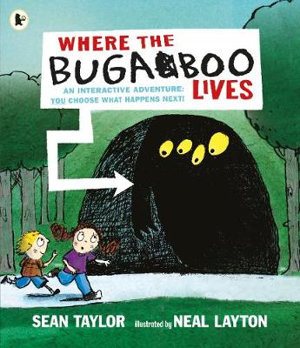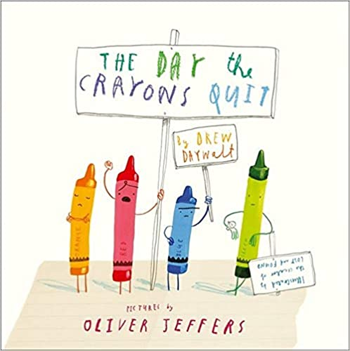 |  |  | 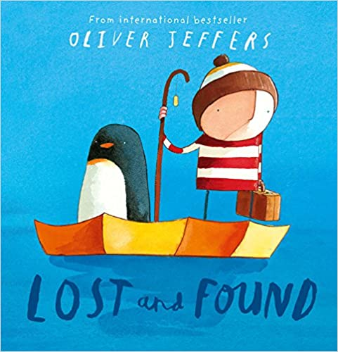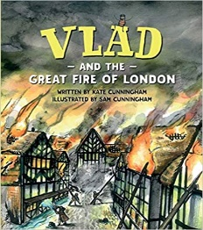
Steps to read | Traditional Tales  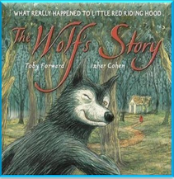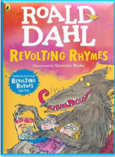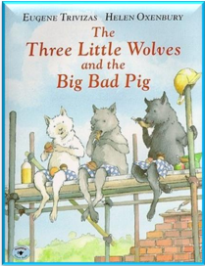  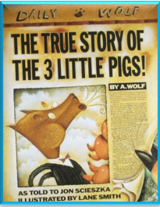 |  |  | River and Seas  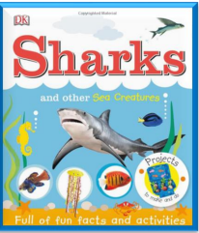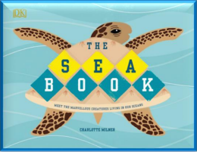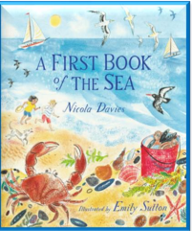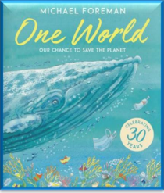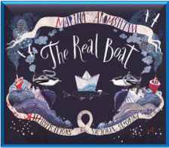 |  |  | The Great Fire of London  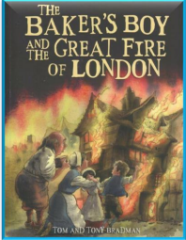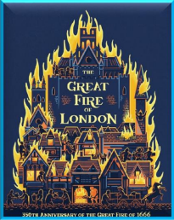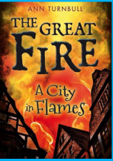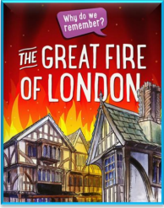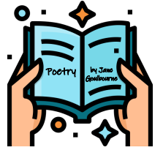
 | Living Things  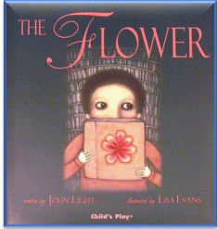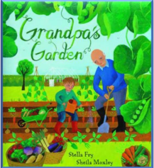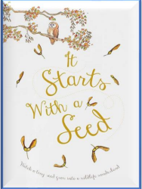  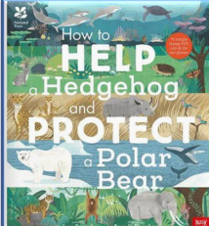 |  |  | Fairy Tales & Poetry  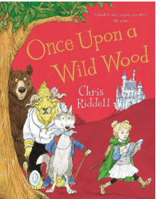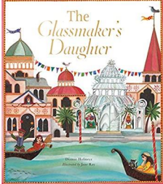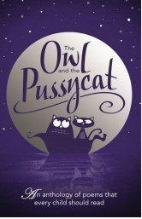  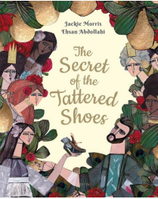 |  |  | Stories and Plays and Poetry  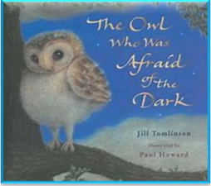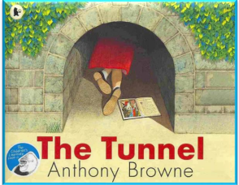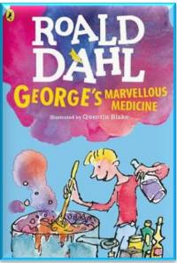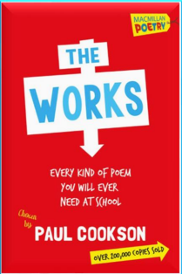
Reading | Phonics (Phase 5) & Spelling Shed (phase 6)  Parachute Reading  Shared Reading  Steps to Read- Literacy Counts  Class novels |  |  | Phonics- Phase 5 & Spelling Shed (phase 6)  Parachute Reading  Shared Reading  Steps to Read- Literacy Counts  Class novels |  |  | Phonics- Phase 6 (Spelling Shed)  Parachute Reading  Shared Reading  Steps to Read- Literacy Counts  Class novels
Maths | See ‘Maths No Problem’ overviews for more information
Science | Exploring Everyday Materials  Suitability of materials, for particular uses.  How some materials can be changed? | Living Habitats |  |  | Growth and survival | Growing  Plants  Plants germinate and grow into seedlings then mature plants.  Conditions plants need water to grow and stay healthy. |  |  |  | Super Scientists |  | Consolidation of prior learning through SC1- Working Scientifically
 | Working Scientifically  Investigations will include: observing, recording, pattern-seeking enquiry, surveying, researching, deep-thinking and simple testing. | Working Scientifically  Investigations will include: observing, recording, pattern-seeking enquiry, surveying, researching, deep-thinking and simple testing. |  |  | Working Scientifically  Investigations will include: observing, sorting, describing, , recording, exploring, problem solving, applying knowledge and investigations over short periods of time. | Working Scientifically  Investigations will include: observing, sorting, describing recording, researching, deep-thinking and simple testing and comparative testing as well as investigations over short periods of time. |  |  |  | Working Scientifically Investigations will include: observing, sorting, describing, classifying, ordering, recording, researching, exploring, investigations over short periods of time. |  | Working Scientifically Investigations will include: observing, sorting, describing, classifying, ordering, recording, researching, exploring, investigations over short periods of time.
Investigations over long periods of time:
Do habitats change during a year?
Does the number of animals found in a habitat change?
History | Liverpool & The Beatles  What was special about Liverpool in the 1960s?  Significant historical events, people and places in their own locality  October Black History Month: Rosa Parks(Blackbird written by Paul McCartney)  Gun Powder, Treason and Plot:  Remembrance Day: Who was Wilfred Owen? |  |  |  | Nurses from History |  |  | Samuel Pepys – Great Fire of London  Events beyond living memory that are significant nationally or globally.  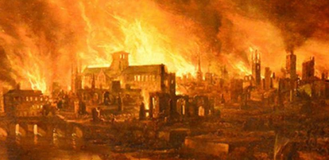
Geography |  | Food and Farming |  |  |  | A Road Trip across the USA |  |  |  |  | Coastlines
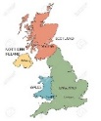
Locational Knowledge
UK: countries, capital cities, seas and cities Know the names of and locate the seven continents of the world
Know the names of and locate the five oceans of the world

Music  Charanga Units of Work | Autumn 1:  Unit: Hands, Feet Heart  Style: South African Music | Autumn 2: Ho Ho Ho Unit: Ho Ho Ho  Style: – A Christmas Song  Other Christmas Songs |  |  | Spring 1:  Unit: I want to play in a band  Style: Rock | Spring 2:  Unit: Zootime  Style: Reggae and musicality |  | Summer 1:  Unit: Friendship Song  Style: Improvisation and composition |  |  | Summer 2:  Unit: Reflect, Rewind and Replay  Style: Classical History of Music and the beginnings of the Language of Music.
Art  Access Art | Liverpool  Steph Dekker  Drawing/Painting |  |  |  | Plant Art  Painting, sculpture  Georgia O’Keefe |  |  | Fire, Fire  Painting/  Collage  Rita Greer
DT |  | Textiles  Templates and joining techniques (Delightful Decorations) |  |  |  | Food & Nutrition  Preparing fruit and vegetables  (Picnic Food) |  |  |  |  | Mechanisms  Wheels and axles (Vehicles)
Computing | Computing systems and networks- IT around us | Creating media- digital photography |  |  | Creating media- Making music | Data and information- Pictograms |  | Programme A  Robot algorithms |  |  | Programme B - An introduction to quizzes
RE | Theme: Creation Story  Concept: God/Creation  Religion: Christianity | Theme: Christmas  Concept: Incarnation  Religion: Christianity |  |  | Theme: Prayer at home  Religion: Islam | Theme: Palm Sunday  Concept: Salvation  Religion: Christianity |  | Theme: Community and Belonging Religion: Islam |  |  | Theme: Hajj  Religion: Islam
PSHE | Unit 1:  Being Me in My World | Unit 2:  Celebrating Difference |  |  | Unit 3:  Dreams & Goals | Unit 4:  Healthy Me |  | Unit 5:  Relationships |  |  | Unit 6:  Changing Me
PE | Unit 1 Attack Defend, Shoot | Unit 1 Attack Defend, Shoot |  |  | Unit 1 Gymnastics  Unit 1 Send & Return | Unit 1 Dance  Unit 2 Send & Return |  | Unit 2 Hit, Catch, Run  OAA |  |  | Unit 1 Run, Jump, Throw  Unit 2 Run, Jump, Throw

