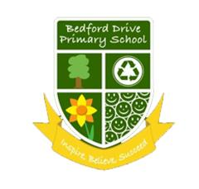
YEAR 1 READING/WRITING
CURRICULUM PLAN 2021-2022

 | AUTUMN 1 |  | AUTUMN 2 | SPRING 1 | SPRING 2 | SUMMER 1 | SUMMER 2
Cross  Curricular Themes | Whole School Connector:  ‘A Moment in Time’  (History & Music)  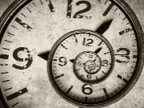 |  |  | Whole School Connector:  ‘Adrift’  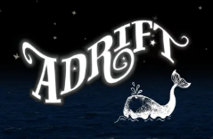  (PSHE / Values / UNICEF) | Whole School Connector:  ‘The Way Things Work’  (Science, DT, Computing)  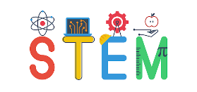 |  | Whole School Connector:  ‘Think Global’  (Geography & Art)
 | Personal Journeys | Toys |  | The Queen |  | Explorers!
 | Materials |  |  | Plants / STEM Project |  | Animals Including Humans
 | Season Change / Weather patterns
Literacy  Counts  Book | 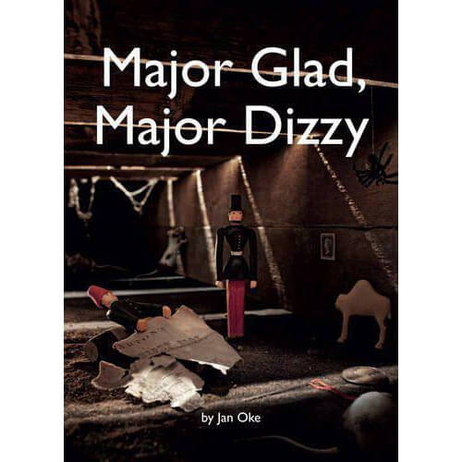 |  | 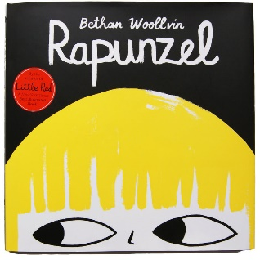 | 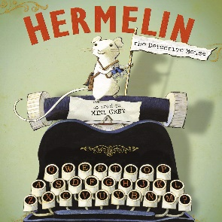 | 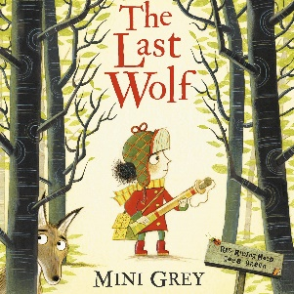 | 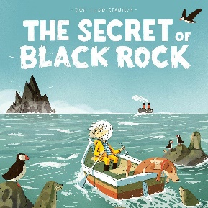 | 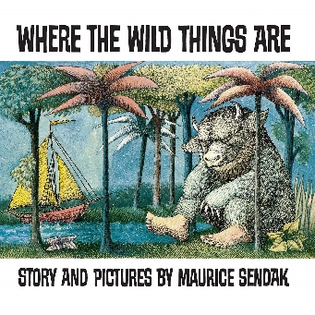
 | Writing descriptions  Story writing |  | Instructional writing  Write a traditional tale |  | Writing a recipe  Story writing | Postcards  Return stories | Information text  Portal stories
Whole  Class  Novel | 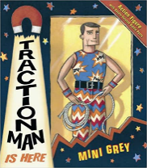  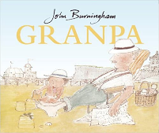  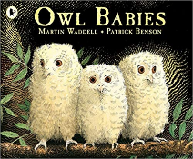  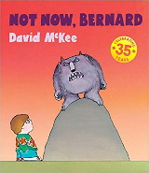 |  |  | 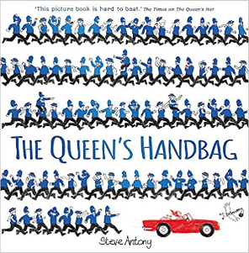  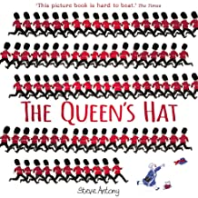  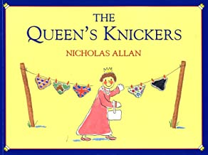  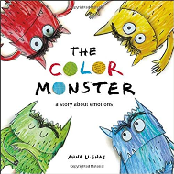  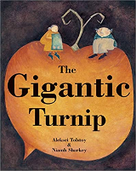 |  | 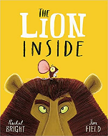  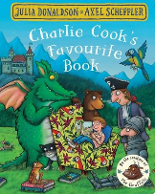  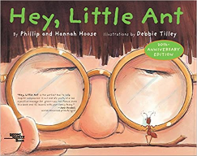
 | Traditional Tales

