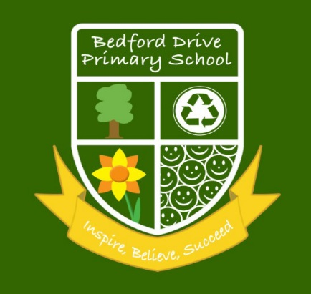

What is SMSC?

SMSC stands for spiritual, moral, social and cultural development.
All schools in England must show how well their pupils develop in SMSC.

At Bedford Drive, SMSC is taught through the curriculum subjects as well as through the schools’ ethos and values. SMSC is embedded through:
- Our Rights Respecting Program
- British Values
- Philosophy for Children
- Values based education
- RE lessons
- Themed weeks throughout the year

These four strands are developed further through visiting speakers, festival and celebration days, Sports Day and charity events e.g. Comic Relief and NSPCC. In addition to quality teaching, pupil’s behaviour, attitudes, achievement and self-esteem all play a big part in developing SMSC at Bedford Drive Primary.
All curriculum subject areas have a responsibility and the potential to promote SMSC/personal development

SMSC development is crucial for individual pupils and for society as a whole. Teachers see it as the heart of what education is about – helping pupils grow and develop as people, to be the best they can be. The importance has repeatedly been recognised by legislators; schools are required by law to promote pupils’ SMSC development and inspectors are required to inspect it’ (Ofsted 2004).

Spiritual  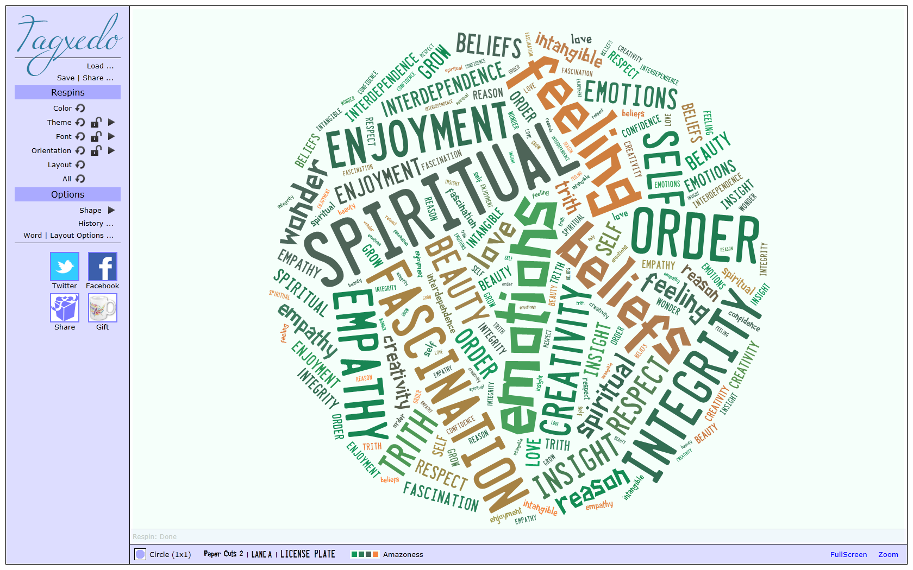 | Experiencing fascination, awe and wonder: Is shown by pupils’ sense of enjoyment and fascination in learning about themselves, others and the world around them, including the intangible | Exploring the values and beliefs of others: Is shown by pupils’ beliefs, religious or otherwise, which inform their perspective on life and their interest in and respect for different people’s feelings and values | Understanding human feelings and emotions: Is shown by pupils’ willingness to reflect on their experiences | Using imagination and creativity in learning: Is shown by pupils’ use of imagination and creativity in their learning
OFSTED 2019 Handbook
The spiritual development of pupils is shown by their:
- ability to be reflective about their own beliefs (religious or otherwise) and perspective on life
- knowledge of, and respect for, different people’s faiths, feelings and values
- sense of enjoyment and fascination in learning about themselves, others and the world around them
- use of imagination and creativity in their learning
- willingness to reflect on their experiences.
For example:
- R.E. lessons – learning about different faiths and reflecting upon different beliefs.
- British Values - mutual respect for and tolerance of those with different faiths and beliefs and for those without faith
- Global learning through RE/ History/Geography topics, which focus on the world around us e.g. countries, Our Planet, Landscapes, Living Things.
- Philosophy for Children sessions to discuss stories and theories that inspire curiosity and wonder.
- Music from other ethnic groups and societies.
- Values based education

Moral  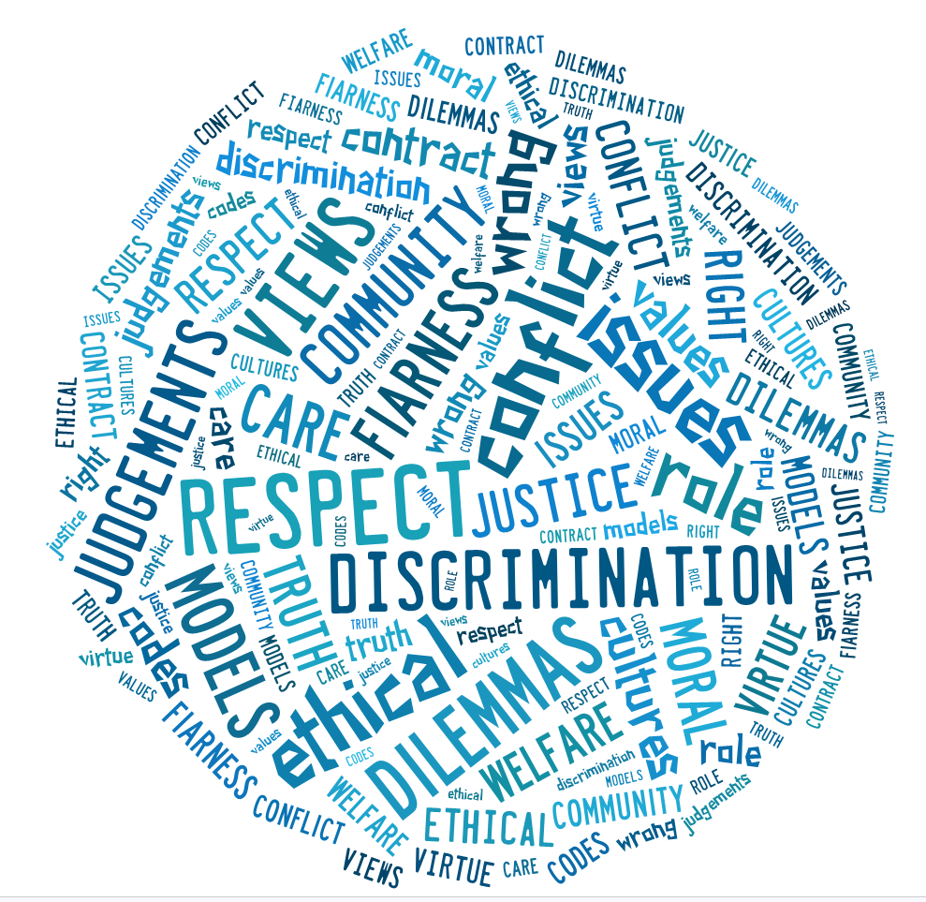 | Investigating moral values and ethical issues: Is shown by pupils’ interest in investigating, and offering reasoned views about, moral and ethical issues | Recognising right and wrong and applying it: Is shown by pupils’ ability to recognise the difference between right and wrong and their readiness to apply this understanding in their own lives | Understanding the consequences of actions: Is shown by pupils’ understanding of the consequences of their actions
OFSTED 2019 Handbook
The moral development of pupils is shown by their:
- ability to recognise the difference between right and wrong and to readily apply this understanding in their own lives, and to recognise legal boundaries and, in doing so, respect the civil and criminal law of England
- understanding of the consequences of their behaviour and actions
- interest in investigating and offering reasoned views about moral and ethical issues and ability to understand and appreciate the viewpoints of others on these issues.
For example:
- Opportunities for debates, Conscience Alley, role play, circle time
- Anti-bullying Week
- Rights Respecting School
- Philosophy for Children: discussions about moral situations and making the right choice
- Diversity Week.
- British Values - the rule of law
- Values based education

Social  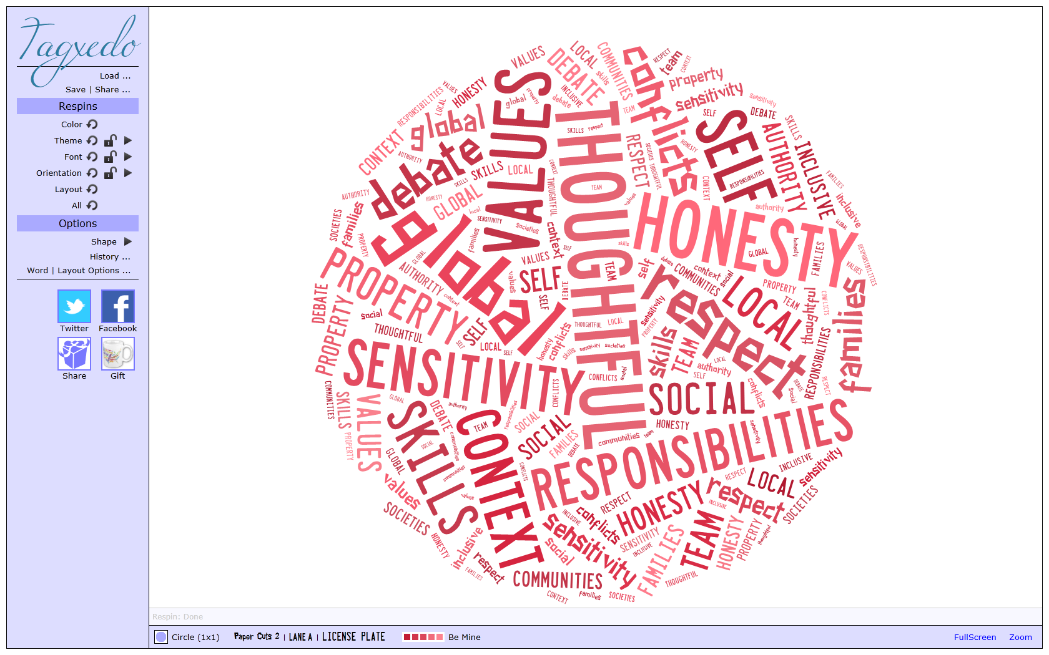 | Developing personal qualities and using social skills: Is shown by pupils’ used of a range of social skills in different contexts, including working and socialising with pupils from different religious, ethnic and socio-economic backgrounds | Participating, cooperating and resolving conflict: Is shown by pupils’ willingness to participate in a variety of social settings, cooperating well with others and being able to resolve conflicts effectively | Understanding how communities and societies function: Is shown by pupils’ interest in, and understanding of, the way communities and societies function at a variety of levels
OFSTED 2019 Handbook
The social development of pupils is shown by their:
- use of a range of social skills in different contexts, for example working and socialising with other pupils, including those from different religious, ethnic and socio-economic backgrounds
- willingness to participate in a variety of communities and social settings, including by volunteering, cooperating well with others and being able to resolve conflicts effectively
- acceptance of and engagement with the fundamental British values of democracy, the rule of law, individual liberty and mutual respect and tolerance of those with different faiths and beliefs. They will develop and demonstrate skills and attitudes that will allow them to participate fully in and contribute positively to life in modern Britain.
For example:
- Collaborative learning opportunities
- Team work to solve problems/dilemmas
- Educational visits
- Sports Day
- Philosophy for Children- taking turns
- Rights Respecting School- speaking out but listening to others too.
- British Values
Cultural  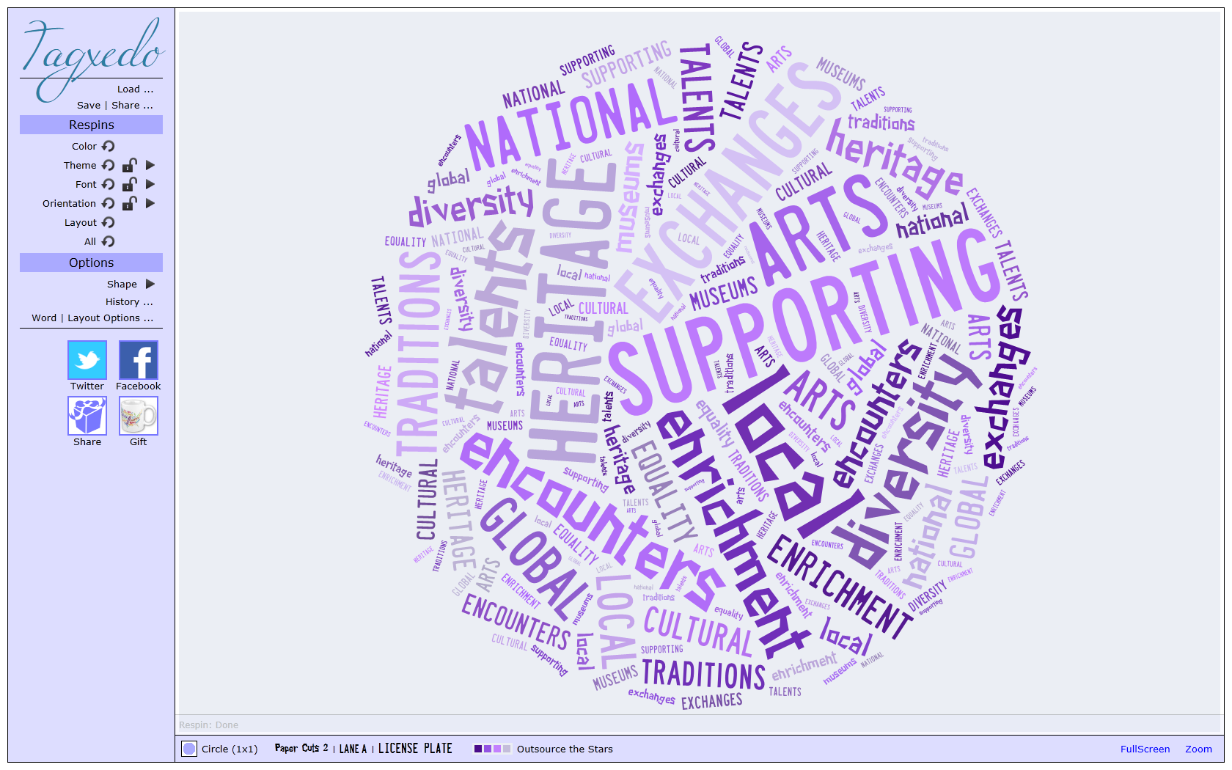 | Exploring, understanding and respecting diversity: Is shown by pupils’ interest in exploring, understanding of, and respect for cultural diversity and the extent to which they understand, accept, respect and celebrate diversity, as shown by their attitudes towards different religious, ethnic and socio-economic groups in the local, nationals and global communities | Participating in and responding to cultural activities: Is shown by pupils’ willingness to participate in, and respond to, for example, artistic, musical, sporting, mathematical, technological, scientific and cultural opportunities | Understanding and appreciating personal influences: Is shown by pupils’ understanding and appreciation of the wide range of cultural influences that have shaped their own heritage
OFSTED 2019 Handbook
The cultural development of pupils is shown by their:
- understanding and appreciation of the wide range of cultural influences that have shaped their own heritage and that of others
- understanding and appreciation of the range of different cultures in the school and further afield as an essential element of their preparation for life in modern Britain
- ability to recognise, and value, the things we share in common across cultural, religious, ethnic and socio-economic communities
- knowledge of Britain’s democratic parliamentary system and its central role in shaping our history and values, and in continuing to develop Britain
- willingness to participate in and respond positively to artistic, musical, sporting and cultural opportunities
- interest in exploring, improving understanding of and showing respect for different faiths and cultural diversity and the extent to which they
understand, accept and respect diversity. This is shown by their respect and attitudes towards different religious, ethnic and socio-economic groups in the local, national and global communities.
For example:
- British Values
- Rights Respecting School
- Historical events and people e.g Guy Fawkes, WW2
- Celebrations – Christmas, Easter
- Assemblies/ R.E. festivals – Eid, Diwali
- Educational visits e.g art galleries, Chester, Roman Museum, Science Museum

