English Overview: Year 5 Non-Negotiables Bedford Drive Primary School 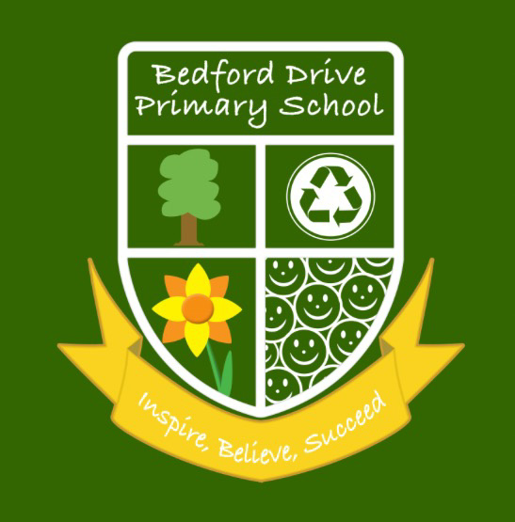

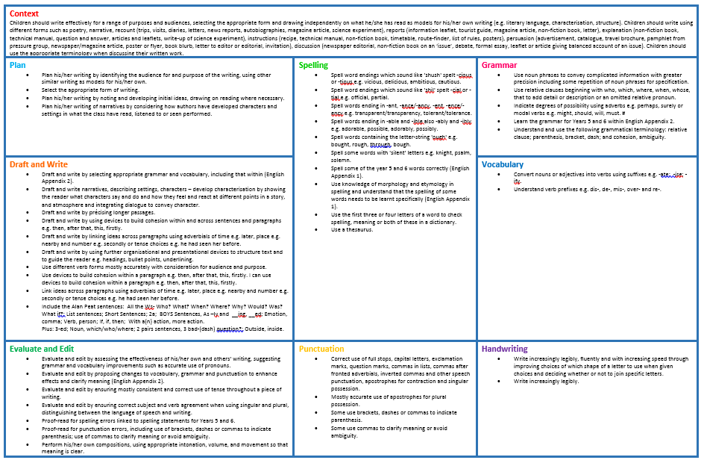

Context
Children should write effectively for a range of purposes and audiences, selecting the appropriate form and drawing independently on what he/she has read as models for his/her own writing (e.g. literary language, characterisation, structure). Children should write using different forms such as poetry, narrative, recount (trips, visits, diaries, letters, news reports, autobiographies, magazine article, science experiment), reports (information leaflet, tourist guide, magazine article, non-fiction book, letter), explanation (non-fiction book, technical manual, question and answer, articles and leaflets, write-up of science experiment), instructions (recipe, technical manual, non-fiction book, timetable, route-finder, list of rules, posters), persuasion (advertisement, catalogue, travel brochure, pamphlet from pressure group, newspaper/magazine article, poster or flyer, book blurb, letter to editor or editorial, invitation), discussion (newspaper editorial, non-fiction book on an ‘issue’, debate, formal essay, leaflet or article giving balanced account of an issue). Children should use the appropriate terminology when discussing their written work.
Plan  - Plan his/her writing by identifying the audience for and purpose of the writing, using other similar writing as models for his/her own.  - Select the appropriate form of writing.  - Plan his/her writing by noting and developing initial ideas, drawing on reading where necessary.  - Plan his/her writing of narratives by considering how authors have developed characters and settings in what the class have read, listened to or seen performed. | Spelling  - Spell word endings which sound like 'shush' spelt -cious or -tious e.g. vicious, delicious, ambitious, cautious.  - Spell word endings which sound like 'shil' spelt -cial or -tial e.g. official, partial.  - Spell words ending in -ant, -ance/-ancy, -ent, -ence/-ency e.g. transparent/transparency, tolerant/tolerance.  - Spell words ending in -able and -ible also -ably and -ibly e.g. adorable, possible, adorably, possibly.  - Spell words containing the letter-string 'ough' e.g. bought, rough, through, bough.  - Spell some words with 'silent' letters e.g. knight, psalm, solemn.  - Spell some of the year 5 and 6 words correctly (English Appendix 1).  - Use knowledge of morphology and etymology in spelling and understand that the spelling of some words needs to be learnt specifically (English Appendix 1).  - Use the first three or four letters of a word to check spelling, meaning or both of these in a dictionary.  - Use a thesaurus. | Grammar  - Use noun phrases to convey complicated information with greater precision including some repetition of noun phrases for specification.  - Use relative clauses beginning with who, which, where, when, whose, that to add detail or description or an omitted relative pronoun.  - Indicate degrees of possibility using adverbs e.g. perhaps, surely or modal verbs e.g. might, should, will, must. #  - Learn the grammar for Years 5 and 6 within English Appendix 2.  - Understand and use the following grammatical terminology: relative clause; parenthesis, bracket, dash; and cohesion, ambiguity.
Draft and Write  - Draft and write by selecting appropriate grammar and vocabulary, including that within (English Appendix 2).  - Draft and write narratives, describing settings, characters – develop characterisation by showing the reader what characters say and do and how they feel and react at different points in a story, and atmosphere and integrating dialogue to convey character.  - Draft and write by précising longer passages.  - Draft and write by using devices to build cohesion within and across sentences and paragraphs e.g. then, after that, this, firstly.  - Draft and write by linking ideas across paragraphs using adverbials of time e.g. later, place e.g. nearby and number e.g. secondly or tense choices e.g. he had seen her before.  - Draft and write by using further organisational and presentational devices to structure text and to guide the reader e.g. headings, bullet points, underlining.  - Use different verb forms mostly accurately with consideration for audience and purpose.  - Use devices to build cohesion within a paragraph e.g. then, after that, this, firstly. I can use devices to build cohesion within a paragraph e.g. then, after that, this, firstly.  - Link ideas across paragraphs using adverbials of time e.g. later, place e.g. nearby and number e.g. secondly or tense choices e.g. he had seen her before.  - Include the Alan Peat sentences: All the Ws- Who? What? When? Where? Why? Would? Was? What if?; List sentences; Short Sentences; 2a; BOYS Sentences, As –ly and __ing, __ed; Emotion, comma; Verb, person; If, if, then; With a(n) action, more action.  Plus: 3-ed; Noun, which/who/where; 2 pairs sentences, 3 bad-(dash) question?; Outside, inside. |  | Vocabulary  - Convert nouns or adjectives into verbs using suffixes e.g. -ate; -ise; -ify.  - Understand verb prefixes e.g. dis-, de-, mis-, over- and re-.
Evaluate and Edit  - Evaluate and edit by assessing the effectiveness of his/her own and others' writing, suggesting grammar and vocabulary improvements such as accurate use of pronouns.  - Evaluate and edit by proposing changes to vocabulary, grammar and punctuation to enhance effects and clarify meaning (English Appendix 2).  - Evaluate and edit by ensuring mostly consistent and correct use of tense throughout a piece of writing.  - Evaluate and edit by ensuring correct subject and verb agreement when using singular and plural, distinguishing between the language of speech and writing.  - Proof-read for spelling errors linked to spelling statements for Years 5 and 6.  - Proof-read for punctuation errors, including use of brackets, dashes or commas to indicate parenthesis; use of commas to clarify meaning or avoid ambiguity.  - Perform his/her own compositions, using appropriate intonation, volume, and movement so that meaning is clear. | Punctuation  - Correct use of full stops, capital letters, exclamation marks, question marks, commas in lists, commas after fronted adverbials, inverted commas and other speech punctuation, apostrophes for contraction and singular possession.  - Mostly accurate use of apostrophes for plural possession.  - Some use brackets, dashes or commas to indicate parenthesis.  - Some use commas to clarify meaning or avoid ambiguity. | Handwriting  - Write increasingly legibly, fluently and with increasing speed through improving choices of which shape of a letter to use when given choices and deciding whether or not to join specific letters.  - Write increasingly legibly.

