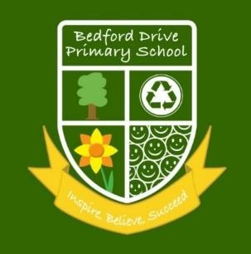

Bedford Drive Primary School 2018-19
These performance measures are for the 2018-19 academic year and are not current. The Government will not publish Key Stage 2 school level data for the 2021-22 academic year. They have archived data from the 2018-19 academic year because they recognise that the data from that year may no longer reflect current performance.
2018/19 Early Years Foundation Stage(EYFS)
55.4 % of children achieved a Good Level of Development (GLD) (National 71.9% 2019)

2018/19 Phonics Screening
72.2 % of the children in Year 1 met the expected standard in the Phonics Screening Check (National 82% 2019)
96.6 % of the children retested in Year 2 met the expected standard in the Phonics Screening Check (National 91% 2019)

2018/19 – Key Stage 1 SATs Report Summary
Attainment (reaching the expected standard and working at greater depth) is as follows:
 | National expected standards, including greater depth 2019 | Bedford Drive expected standards, including greater depth 2019 | National working at greater depth  2019 | Bedford Drive working at greater depth  2019
Reading | 75% | 66.7% | 25% | 20%
Writing | 69% | 60 % | 14.8% | 1.7%
Mathematics | 76% | 70 % | 21.8% | 10%
Combined  Reading, Writing and Maths | 65% | 53.3% | 11.2% | 1.7%
At Key Stage 1 Teacher Assessment is undertaken alongside national test to build a picture of attainment. These judgements are moderated within school and on a planned cycle by the Local Authority.

2018/19 – Key Stage 2 SATs Report Summary
Attainment (reaching the expected standard and achieving higher standard) is as follows:
 | National expected standards, including greater depth/higher standard 2019 | Bedford Drive expected standards, including greater depth /higher standard 2019 | National working at higher standard 2019 | Bedford Drive working at greater depth /higher standard  2019
Reading | 73% | 61% | 27% | 13%
Writing | 78% | 74 % | 20% | 4%
GPS(grammar, punctuation and  spelling) | 78% | 63% | 36% | 20%
Mathematics | 79% | 74 % | 27% | 17%
Combined  Reading, Writing and  Mathematics | 65% | 57% | 11% | 0%

Scaled Scores
 | Average Scaled  Score National 2019 | Average Scaled  Score Bedford Drive 2019 | % of children scoring  95-99
Reading | 104 | 101 | 22%
GPS(grammar, punctuation and  spelling) | 106 | 103 | 17%
Maths | 105 | 102 | 7%
The scaled score runs from 80 to 120
100 is the expected standard

Average Progress Scores
Bedford Drive Primary | Progress Score 2019
Reading | -3
Writing | -2
Mathematics | -2.7

